1. To find air gap flux density

$Hgap=\frac{NI}{g}$ =120\*100/0.01=12\*105 (A/m)

= 1.51 Tesla

1. To find L theoretically,

$R=\frac{lm}{μ*A}$

$R=\frac{0.01m}{4π*{10}^{-7}*0.02m^{2}}$ =397887.35Ω (Width is 1 m default)

=1002/397887.35=25.1 mH

1. Non Saturated Ferrite

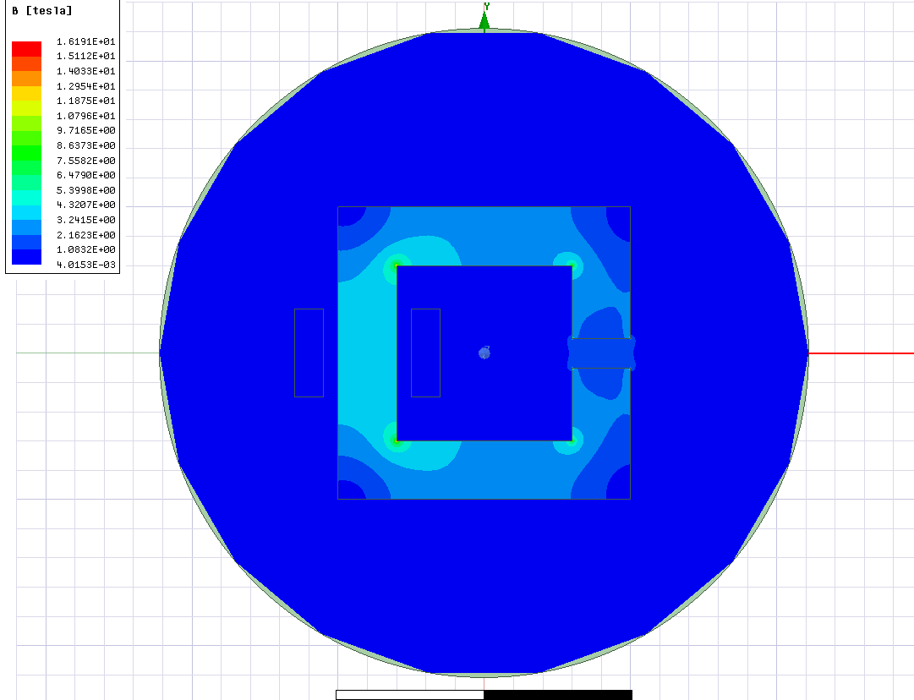

Figure 1: Flux Density for nonsaturated ferrite

When magnetic Flux density is examined for nonsaturated ferrite (Figure 1 in images/Nonsaturated ferrite folder), B is around 1.5 Tesla and it corresponds to theoretical calculations.

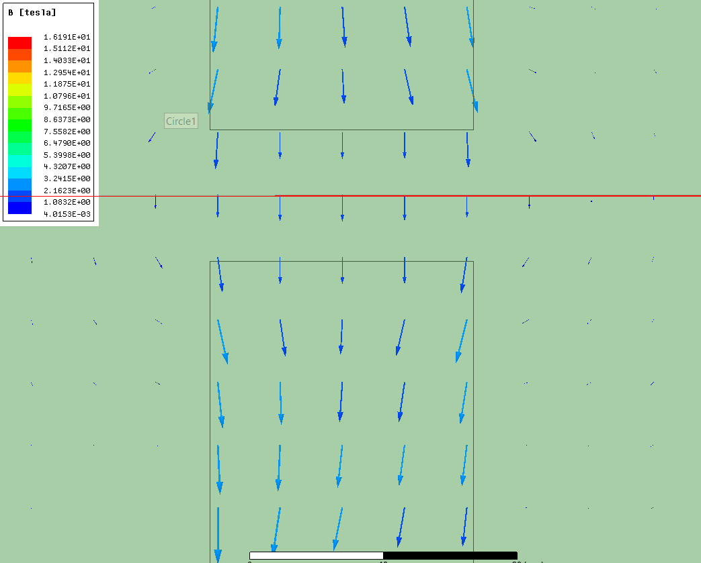

Figure 2: Flux Density vectors for nonsaturated Ferrite

In Figure 2, it is shown that there is fringing flux. (Small vectors which are out of the coil direction are fringing flux vectors.)

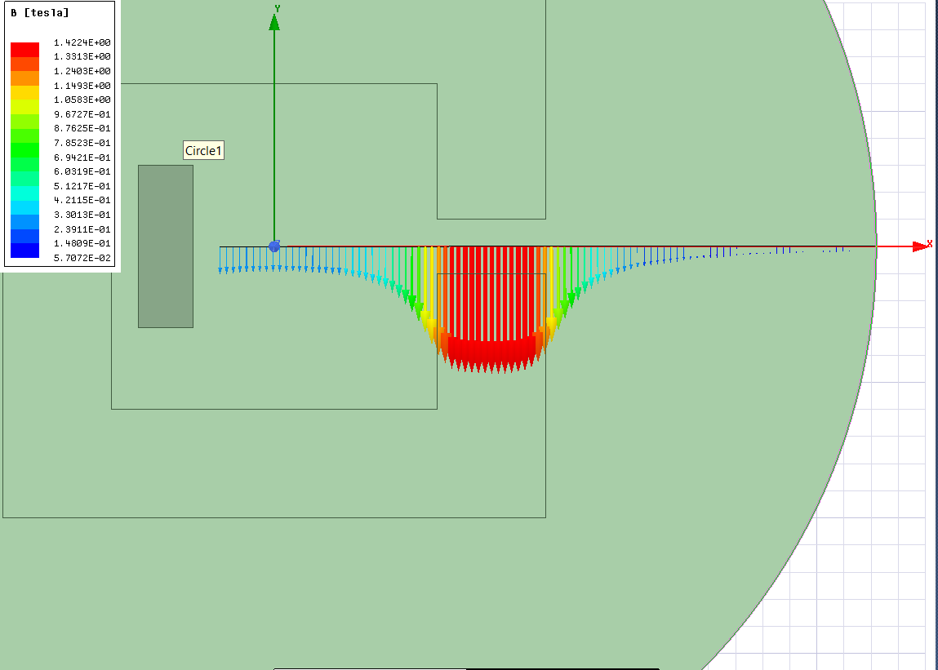

Figure 3: Airgap Flux Density Vectors for non saturated Ferrite

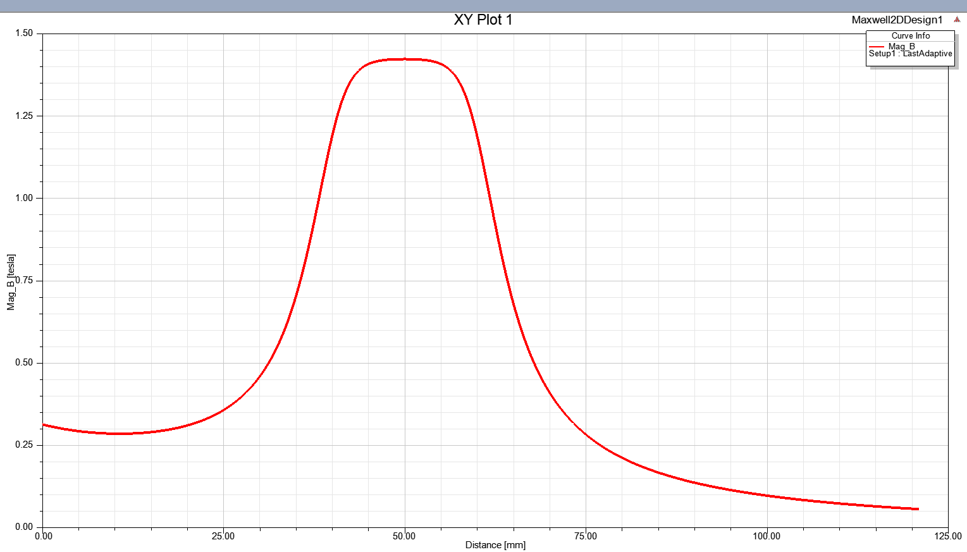

Figure 4: Airgap Flux density Distribution for non saturated Ferrite

Also, in Figure 3, it is shown that Flux vectors are more powerful in the direction of core. Vectors will decrease at the outside.

1. Saturated Steel

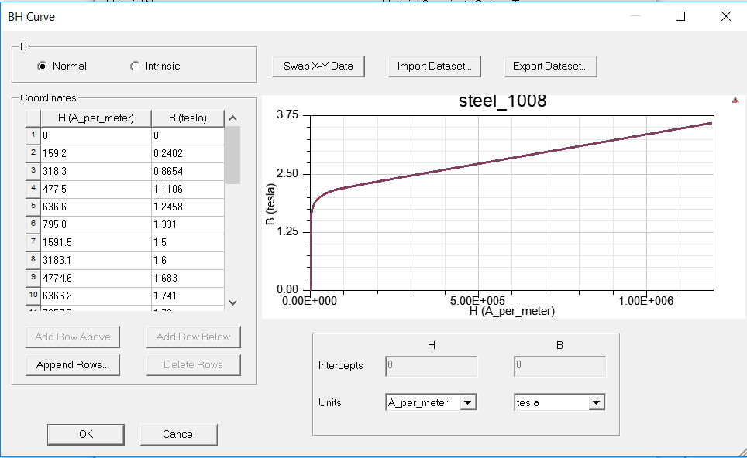

Figure 5: B-H Characteristics of Saturated Steel

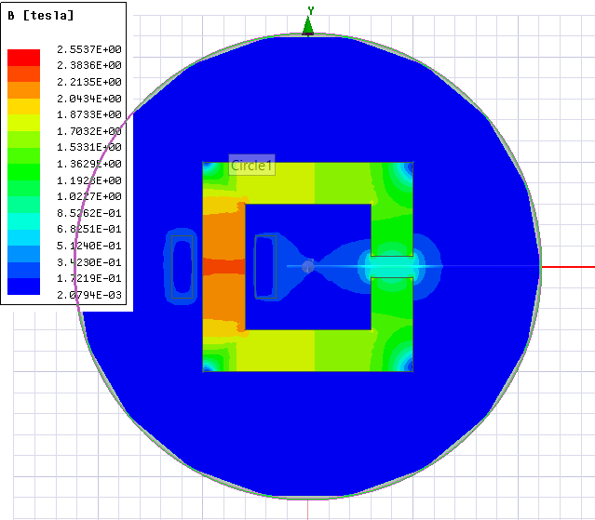

Figure 6: Flux Density of Saturated Steel

Steel have saturated B-H characteristics as shown in Figure 5. Therefore, magnetic flux density does not exceed 2.5 tesla as shown in figure 6.

Flux density distribution and air gap flux density vectors were also added to images folder.

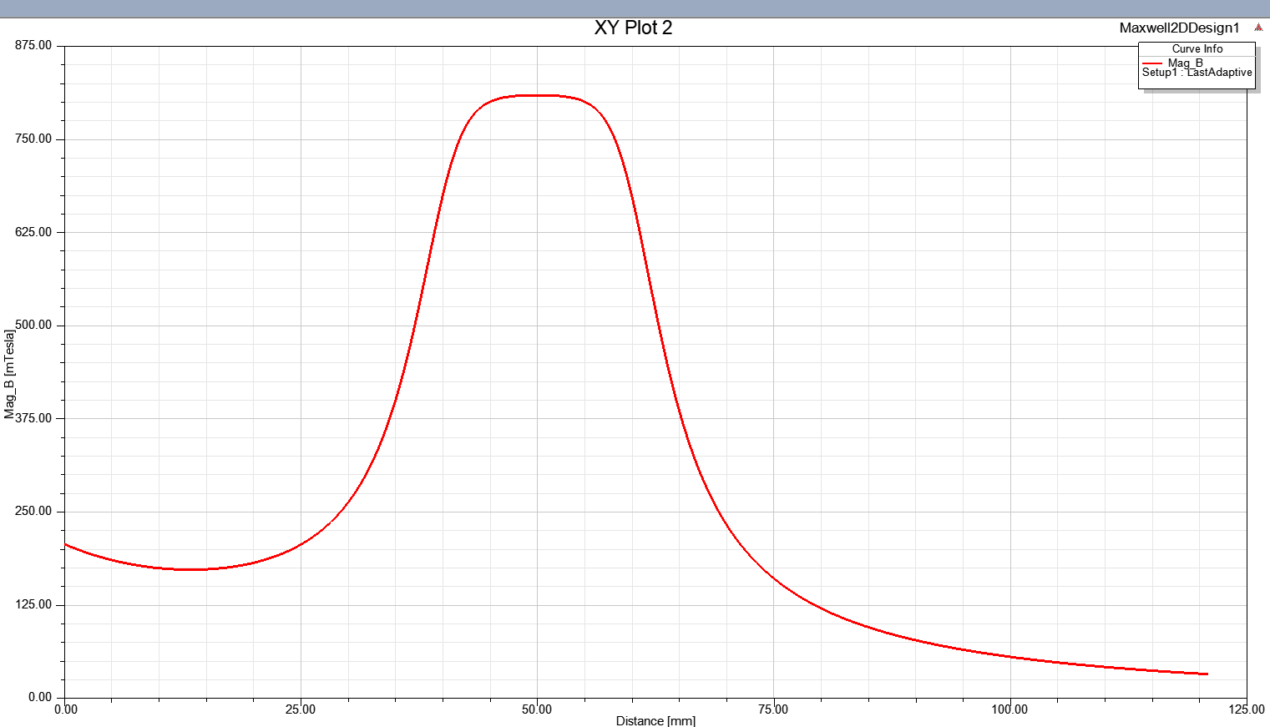

Figure 7: Flux density Distribution Graph for saturated steel

I also examined magnetic flux density characteristic for saturated steel. At the first case 12000 A is applied. After that 120000 A is applied. Whereas current is increased 10 times, flux density increased 2 times as shown in Figure 6 and Figure 8. Because steel has saturated characteristic.

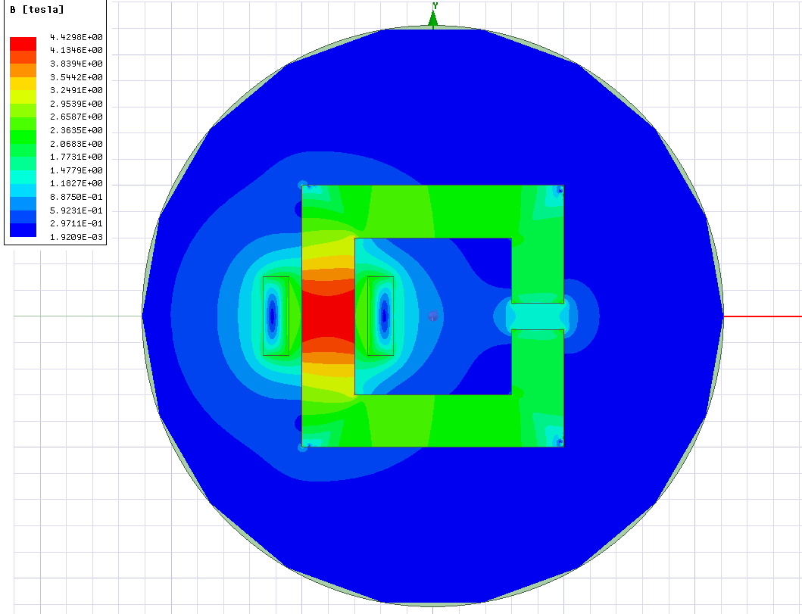

Figure 8: Magnetic Flux density for saturated Steel at 120000 A